apartments.io

Система для керування процесом оренди помешкань та опрацювання запитів орендарів.

**Ролі:** мешканець, менеджер, адміністратор

|  |  |
| --- | --- |
| **Role** | **Description** |
| Мешканець | Мешканець може переглядати свою інформацію (термін дії оренди, список запитів, представлені рахунки та стан їхньої оплати).  Він отримуватиме нотифікації про те що йому виставили рахунки і що його оплата була зарахована менеджером.  Також він отримуватиме нотифікацію про те, що його оренда завершиться через 2 місяці. |
| Менеджер | Менеджер може створювати "апартаменти", закріплювати їх до мешканців, опрацьовувати запити мешканців, виставляти рахунки та редагувати їхній статус.  Менеджер має мати звіти по оплаті рахунків мешканцями, їхні заборгування.  Він може перевіряти наявність вільних апартаментів та таких, котрі будуть звільнені у найближчі 2 місяці.  Виставлені рахунки мають мати статуси "очікують оплати", "оплачені", "протерміновані", "оплачені з запізненням". |
| Адміністратор | Адміністратор може створювати користувачів, деактивовувати користувачів.  Він може додавати користувачів у підпорядкування певному менеджеру. |

|  |  |  |  |
| --- | --- | --- | --- |
| **Controller Name** | **Action Name** | **Test Method Name** | **Description** |
| UserPage | Index | IndexUserPageTest | Shows main page for user |
| Apartment | ApartmentUserPageTest | Shows a page with a list of available apartments |
| Rent | RentUserPageTest | Shows a page with a list of rented apartment |
| Request | RequestUserPageTest | Shows a page with a list of user request |
| Bill | BillUserPageTest | Shows a list of users bill |
| Notification | NotificationUserPageTest | Shows a list of users notification |
| About | — | Shows about page for user |
| Contact | — | Shows contact page for user |
| Privacy | — | Shows privacy page for user |
| ManagerPage | Index | IndexManagerPageTest | Shows main page for manager |
| Apartment | ApartmentManagerPageTest | Shows apartments page for manager |
| Request | RequestManagerPageTest | Shows request page for manager |
| Bill | BillManagerPageTest | Shows bill page for manager |
| AdminPage | Index | IndexAdminPageTest | Shows main page for admin |
| User | UserAdminPageTest | Shows user page for admin |
| Manager | ManagerAdminPageTest | Shows managers page for admin |
| User | Create | CreateUserTest | Creates new user |
| Update | UpdateUserTest | Updates user by id |
| Delete | DeleteUserTest | Deletes user by id |
| Request | Create | CreateRequestTest | Creates new request |
| Update | UpdateRequestTest | Updates request by id |
| Delete | DeleteRequestTest | Deletes request by id |
| Bill | Create | CreateBillTest | Creates new bill |
| Update | UpdateBillTest | Updates bill by id |
| Apartment | Create | CreateApartmentTest | Creates new apartment |
| Update | UpdateApartmentTest | Updates apartment by id |
| Delete | DeleteApartmentTest | Deletes apartment by id |

## **Resident Management**

|  |  |  |  |  |  |  |
| --- | --- | --- | --- | --- | --- | --- |
| **№** | **Use Case** | **Role** | **Controller** | **Description** | **Action Method** | **Test Method** |
| RM1 | — | Resident | UserPage | Shows main page for user | Index() | IndexTest() |
| RM2 | Show list of apartments | Shows a page with a list of available apartments | Apartment() | ApartmentTest() |
| RM3 | Show apartments  which are yours | Shows a page with a list of rented apartment | Rent() | RentTest() |
| RM4 | Show list of user requests | Shows a page with a list of user request | Request() | RequestTest() |
| RM5 | Show list of user bills | Shows a list of users bill | Bill() | BillTest() |
| RM6 | Show list of user notifications | Shows a list of users notification | Notification() | NotificationTest() |
| RM7 | — | Shows about page for user | About() | — |
| RM8 | — | Shows contact page for user | Contact() | — |
| RM9 | — | Shows privacy page for user | Privacy() | — |
| RM10 | Delete himself | User | Deletes user by id | Delete(...) | DeleteUserTest() |
| RM11 | Create request | Request | Creates new request | Create(...) | CreateRequestTest() |
| RM12 | Delete request | Deletes request by id | Delete(...) | DeleteRequestTest() |

## **Manager Management**

|  |  |  |  |  |  |  |
| --- | --- | --- | --- | --- | --- | --- |
| **№** | **Use Case** | **Role** | **Controller** | **Description** | **Action Method** | **Test Method** |
| MM1 | — | Manager | ManagerPage | Shows main page for manager | Index() | IndexTest() |
| MM2 | Show list of apartments | Shows apartments page for manager | Apartment() | ApartmentTest() |
| MM3 | Show list of user requests | Shows request page for manager | Request() | RequestTest() |
| MM4 | Show list of user bills | Shows bill page for manager | Bill() | BillTest() |
| MM5 | Process request | Request | Updates request by id | Update(...) | UpdateRequestTest() |
| MM6 | Delete request | Deletes request by id | Delete(...) | DeleteRequestTest() |
| MM7 | Create request | Bill | Creates new bill | Create(...) | CreateBillTest() |
| MM8 | Change bill status | Updates bill by id | Update(...) | UpdateBillTest() |
| MM9 | Create apartment | Apartment | Creates new apartment | Create(...) | CreateApartmentTest() |
| MM10 | Set apartment owner | Updates apartment by id | Update(...) | UpdateApartmentTest() |
| MM11 | Delete apartment | Deletes apartment by id | Delete(...) | DeleteApartmentTest() |

## 

## **Admin Management**

|  |  |  |  |  |  |  |
| --- | --- | --- | --- | --- | --- | --- |
| **№** | **Use Case** | **Role** | **Controller** | **Description** | **Action Method** | **Test Method** |
| AM1 | — | Admin | AdminPage | Shows main (user) page for admin | Index() | IndexTest() |
| AM3 | Create user | User | Creates new user | Create(...) | CreateUserTest() |
| AM4 | Update user | Updates user by id | Update(...) | UpdateUserTest() |
| AM5 | Delete user | Deletes user by id | Delete(...) | DeleteUserTest() |

# Use Case diagram

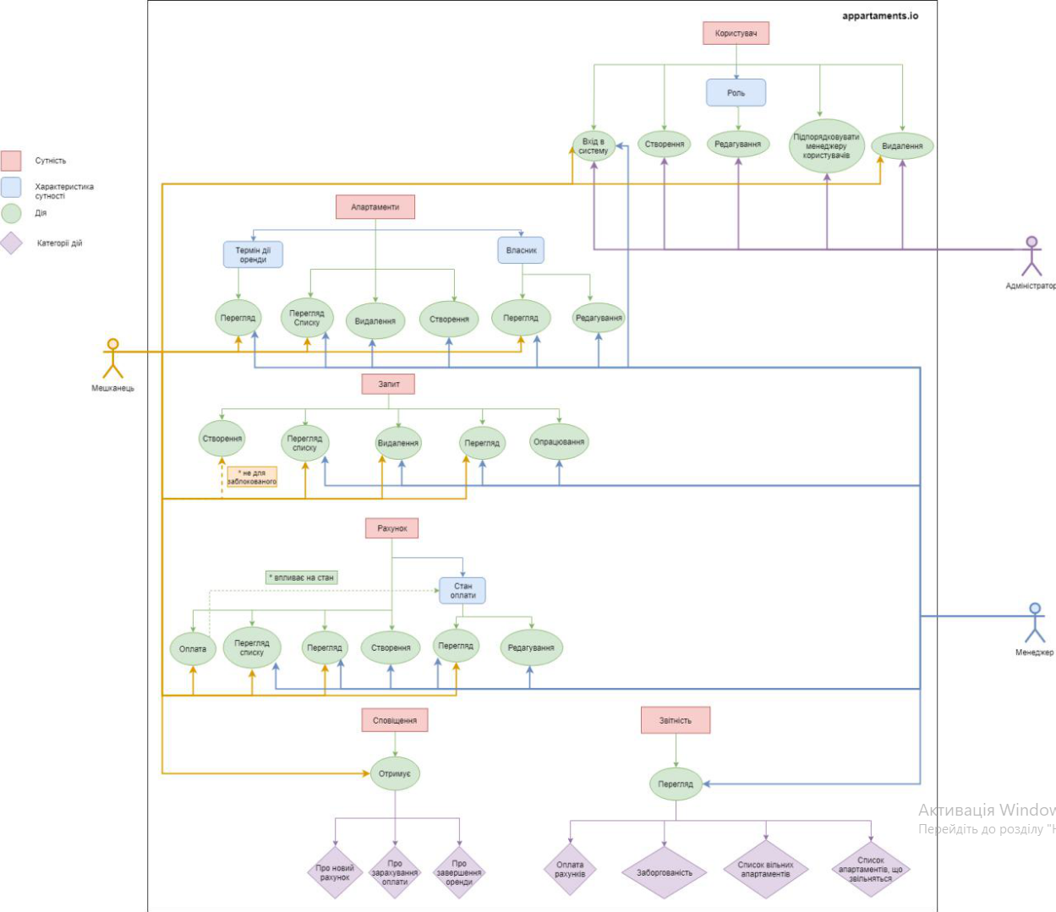

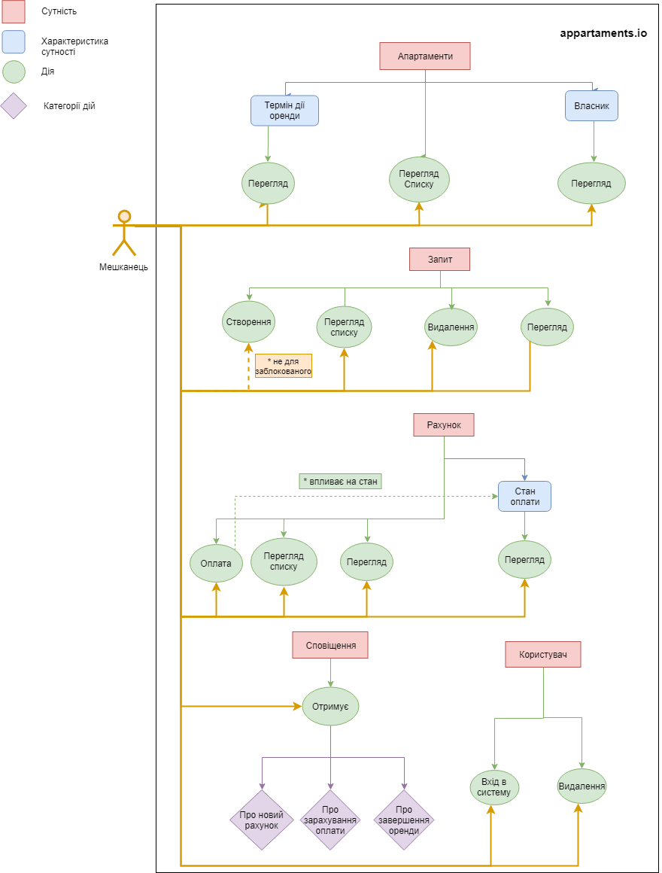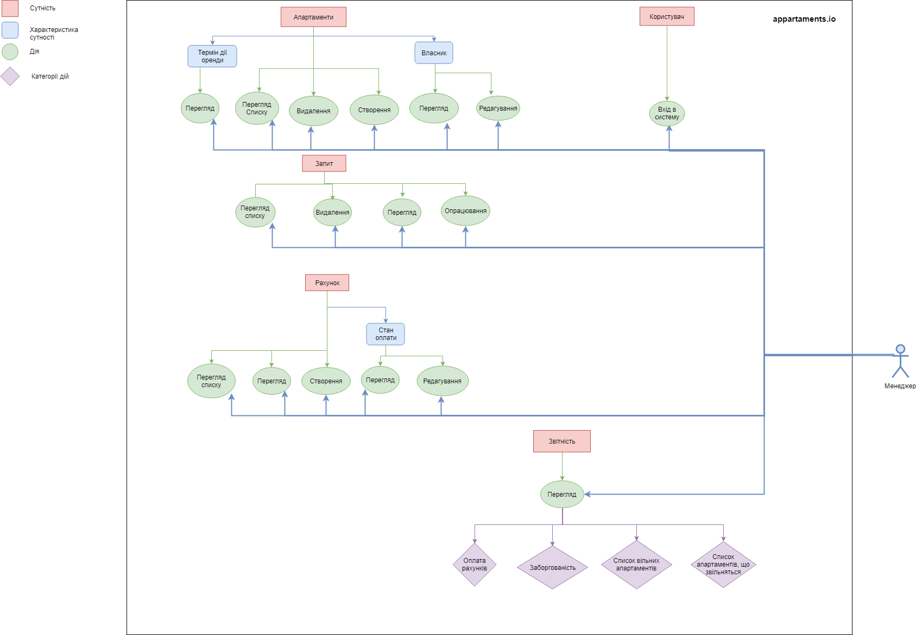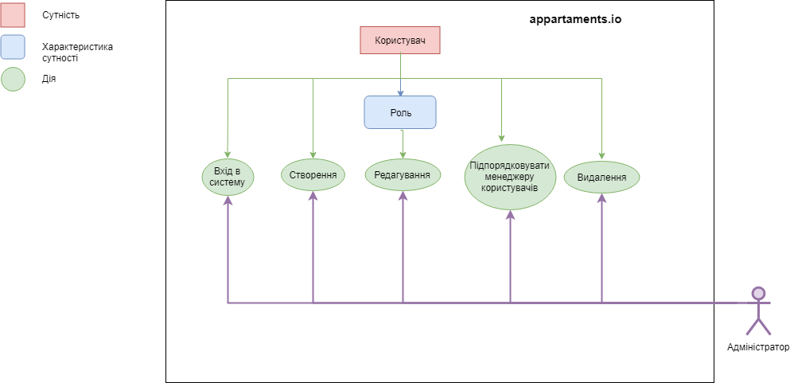

# ER diagram

# 

# 

# 

# 

# 

# Sequence diagram

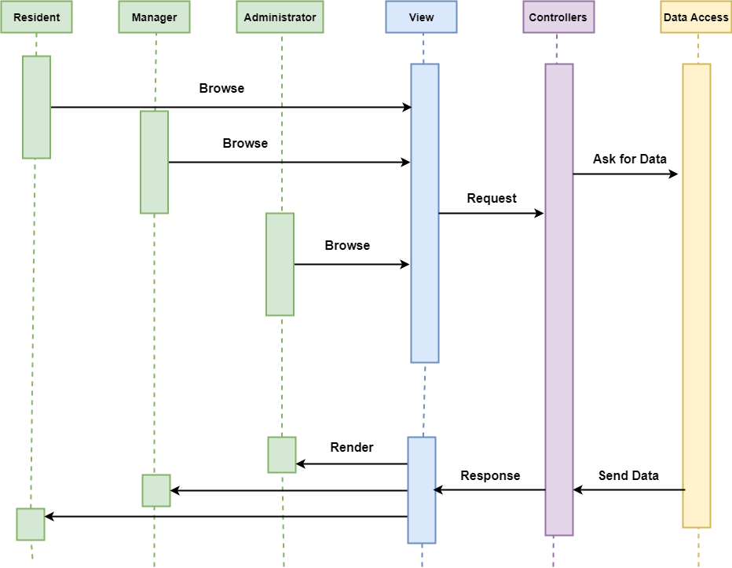

# Domain models diagram

### Main project

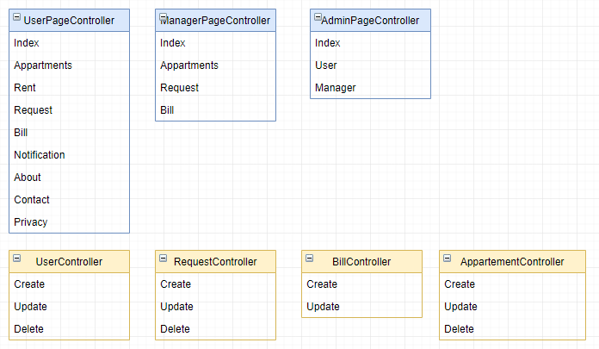

### Data access project:

# Mokups

## Resident

## 

## Administrator

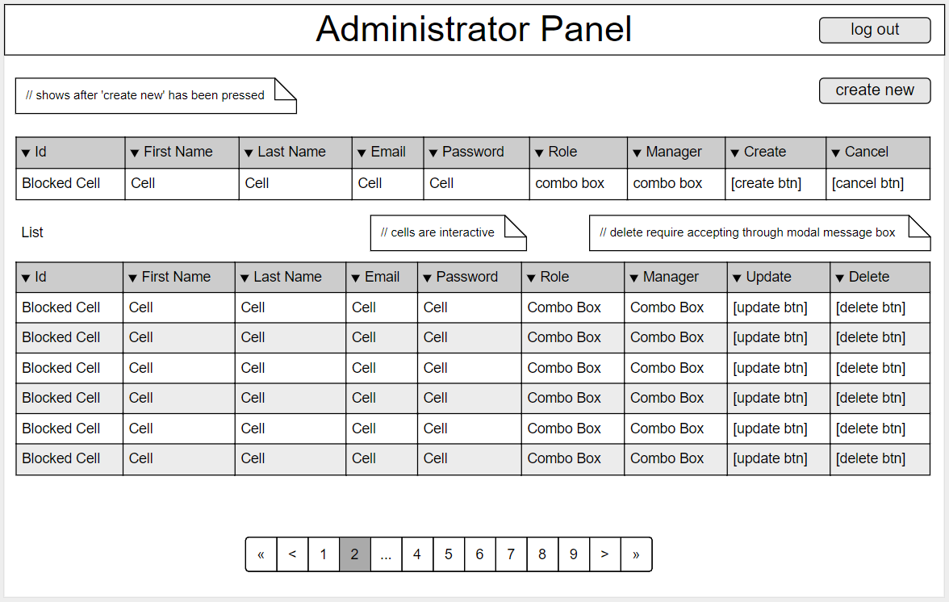

## Manager